The program will ask for the directory where the torrent file will be saved, as well as the credentials of the email account which the program will check.

**Note:** Password will not echo anything because getpass() is used.

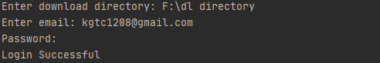

If the login attempt was successful and a new email which has a valid *archive.org* link is found, the program will then go to the website and download the torrent.

It will then wait for 2 minutes before checking again.

C:\Users\hp-user\AppData\Local\Microsoft\Windows\INetCache\Content.Word\received_email.pngC:\Users\hp-user\AppData\Local\Microsoft\Windows\INetCache\Content.Word\new_download.png



If the email found is the same as the last one, It will not download the torrent.



**Note:** *Allow Less Secure Apps* setting from the email account to be checked must be turned ON.